# AEM: Sling API vs JCR API

<https://myprogressivelearning.wordpress.com/2016/01/23/aem-sling-api-vs-jcr-api/>

The technology stack of this typically contains Sling as a web application framework and  
JCR (Jackrabbit) as content repository API.

**Sling** is a web application framework by Apache foundation. It process the HTTP request in RESTful way. This is used to create content centric applications on top of JCR. It deploys the application as OSGi bundles.

**Jackrabbit** – It is a Java Content Repository API. Its fully compliance to the JCR standardizations (JSR). It considers all the content as tree structure (parent-child relationship) i.e., hierarchy of nodes.

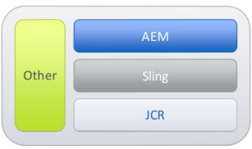

Which is the better one? Sling / JCR

